Noson Deuluol gyda’r Welsh Whisperer
Nos Fercher, Mai 22ain am 6.30 yn Neuadd Ysgol Glanrafon
Diolch o galon i chi am eich syniadau gwych ar gyfer ein Wythnos Cymru Cŵl. Rydym wedi trafod nifer o’ch syniadau gyda’r Llysgenhadon Iaith ac yn mynd ati rwan i drefnu y gweithgareddau. Bydd mwy o fanylion am yr wythnos yn cael eu hanfon atoch yn fuan.
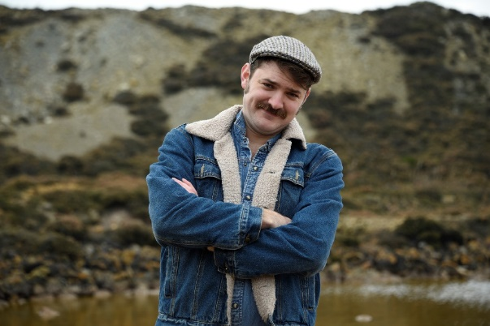
Roedd nifer fawr ohonoch fel rhieni wedi gofyn i ni drefnu noson gymdeithasol felly rydym yn hynod o falch i allu cyhoeddi fod y “Welsh Whisperer” yn dod atom. Fe fydd y Welsh Whisperer yn treulio diwrnod cyfan yn yr ysgol gyda’r nod o gyfansoddi cân newydd sbon - un o’ch syniadau chi fel rhieni eto! Yna, fe fydd y Welsh Whisperer yn aros gyda’r nos i gynnal noson deuluol ar Nos Fercher, Mai 22ain.

Diddanwr canu gwlad a chomedi a chyflwynydd radio a theledu o Sir Gaerfyrddin ydy'r Welsh Whisperer. Mae'n adnabyddus am ei ganeuon canu gwlad gwerinol ond mae hefyd wedi arbrofi gyda chaneuon gwerin a phop â chomedi ynddynt hefyd. Mae o wir yn gymeriad hoffus ac rydym yn sicr y gwnewch fwynhau ei gwmni. Am fwy o wybodaeth amdano, ewch i’r Wȇ.
Os hoffech archebu tocynnau, llenwch y bonyn isod os gwelwch yn dda a’i ddychwelyd i’r ysgol erbyn Dydd Gwener, Mai 17eg. Mae rhaid gyrru’r arian cywir gyda’r bonyn i sicrhau eich tocynnau. Sieciau yn daladwy i ysgol Glanrafon.
Gobeithiwn y bydd y Welsh Whisperer a chithau yn cael noson hwyliog a bythgofiadwy!!!
___________________________________________________________________________

Enw :- ____________________________ Dosbarth :- _________________

Hoffwn archebu tocynnau ar gyfer noson y Welsh Whisperer, ac rwyf yn gyrru yr arian cywir i’r ysgol.

Oedolion (£5 yr un) :- ___ o docynnau Plant (£2 yr un) :- ___ o docynnau

Cyfanswm eich archeb :- £_____

A family evening with the Welsh Whisperer

Wednesday evening, May 22nd at Ysgol Glanrafon at 6.30

Thank you so much to you as parents for your fantastic ideas for our Cymru Cool week. Our Language Ambassadors have been discussing your ideas and we are now in the process of organizing various activities. More information will be sent to you very soon.

A vast majority of you as parents asked for us to organize a social evening so we are very pleased to announce that the Welsh Whisperer will be coming to Ysgol Glanrafon. He will be spending a whole day with the pupils composing a special song – another idea from yourselves. Then, a social evening for the whole family will be led by the Welsh Whisperer that evening on Wednesday, May 22nd.

The 'Welsh Whisperer' is a Welsh country folk pop performer, radio presenter & television personality. He was born in Carmarthen and has made multiple appearances on Welsh radio and television comedy programmes. He is certainly a unique character and we’re sure that you will enjoy his company. For more information about him, please search the Internet.
If you would like to order tickets, please fill in the slip below and send it into school by Friday, May 17th. Please note that the money needs to be sent in with the slip to guarantee tickets. All cheques made payable to Ysgol Glanrafon.

We do hope that the Welsh Whisperer and yourselves will have a fun filled and memorable evening!!

Name :- ______________________________ Class :- ______________

I/We would like to order tickets for the Welsh Whisperer evening. I/We enclose the correct money for the tickets.

Adults (£5 each) :- ____ tickets Children (£2 each) :- ____ tickets

Full amount of order :- £_____

