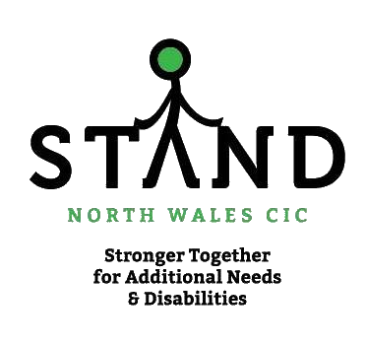

Oracy Cambridge
Hughes Hall

Hughes Hall Cambridge CB1 2EW
Tel: +44 (0)1223 767592
Email: nnm31@cam.ac.uk
Web: www.hughes.cam.ac.uk

STAND North Wales CIC Workshop:
Making The Most of Talk in School

Date: |  | 24th March 2022
Venue: |  | The Oriel Hotel & Spa  Upper Denbigh Road  St. Asaph  Denbighshire  LL17 0LW
Costings: |  | £140.00 per professional  £40.00 per parent

Delivered by Neil Mercer and Wendy Lee

Bios:

Professor Neil Mercer

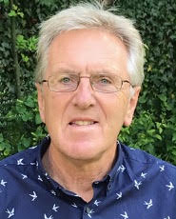

Neil Mercer is Emeritus Professor of Education at the University of Cambridge and Director of Oracy Cambridge: the Centre for Effective Spoken Communication, at the Cambridge college Hughes Hall. He is a psychologist whose research has focused on the development of children’s spoken language and reasoning abilities and teachers’ role in that development. He has worked extensively and internationally with teachers, researchers and educational policy makers.

He was given the Oevre Award by the European Association for Research into Learning and Instruction and the John Nisbet Fellowship by the British Educational Research Association for outstanding contributions to educational research. His books include Words and Minds and Interthinking: putting talk to work.

https://www.hughes.cam.ac.uk/academic/our-people/seniors-members/neil-mercer/

Wendy Lee

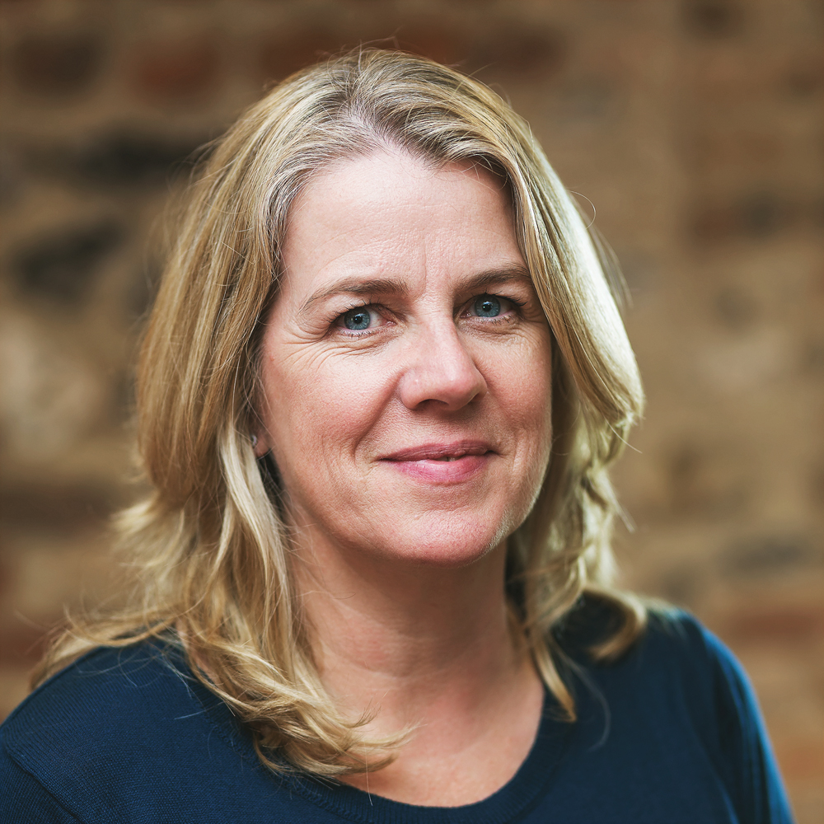

Wendy has worked as a speech and language therapist for over 30 years, in clinical practice, higher education and the third sector. She was Professional Director at The Communication Trust until 2015 where she led on a number of projects, as well as inputting on national policy and research.

Wendy is currently the Director of LINGO, which provides consultancy, professional development, resources and speech and language therapy. She works with schools and settings and is involved in research into shared reading to support early language.

Outline of the day:

Time | Task
09:30 – 09:45 | Welcome and introductions (STAND North Wales CIC)
09:45 – 10:45 | What oracy is and why it matters  Professor Neil Mercer will explain what is known about the importance of children’s spoken language experience for the development of their reasoning, their academic attainment and their life chances in general. He will relate first this to how teachers can use talk most effectively to help children learn. He will then describe ways that have been found effective for developing young people’s oracy skills – for example, those needed to work well together in groups of teams.
10:45 – 11:00 | Questions and discussion
11:00 – 11:30 | Coffee Break
11:30 – 12:30 | Oracy and Inclusion  Wendy Lee will talk about the challenges that can be experienced by children with speech, language and communication needs and how to overcome some of those challenges. We will explore what teachers can do to ensure inclusion of these children and strategies we can teach the children themselves so they can access and make best use of effective talk in the classroom.
12:30 – 13:45 | Lunch
13:45 – 14:45 | Oracy in Context  A discussion session led by Neil and Wendy. Neil will first set out some issues which have arisen in other initiatives we have been involved in, and how these have been successfully tackled. He will also make the links between the research and the Wales curriculum. Wendy will talk through inclusive Oracy from a pupil perspective and consider how when listening to pupils with additional needs, we can translate their views into practice.  Then, in groups, participants will consider (a) how these issues relate to their practice in supporting children’s learning (b) adaptations that will support the children they know and work with (c) beginning to discuss practical plans for acting upon the content of today’s workshop
14:45 – 15:15 | Break
15:15 – 15:45 | Final Review Session  Report back from groups, general discussion of what has emerged from the group discussions and consolidation of any matters taken forward

BOOKING FORM

Please reserve place(s) for ‘Making the Most of Talk in School’ one day training on Thursday 24th March 2022 at The Oriel Hotel and Spa, St. Asaph, Denbighshire.

COST TO ATTEND includes training day, buffet lunch & refreshments

Name of person(s) attending:
Job title / parent:
Correspondence address: | Invoice address:
Contact telephone number:  (Work contact number for professionals) | Invoice contact number:
Attendees email address: | Invoice email address:
Attendees contact number: | Purchase Order number:
PAYMENT INFORMATION
I enclose a cheque for £
Please make cheques payable to Stand North Wales CIC
For Parents: Please indicate how you wish to make the payment | Paypal  Bank transfer  Cheque
For Professionals: Please indicate how you wish to make payment.
If you choose invoice, we cannot take any bookings without the Purchase Order number, so please provide this when booking

Invoice – PO number required
Cheque: Please make cheques payable to STAND North Wales CIC

You will need to post a copy of your booking form with your cheque when a place has been confirmed by our admin. You will be provided with the details of this when confirmed.
REQUIREMENTS
Please complete this section. If you have no requirements, please state so.
Dietary requirements:
e.g vegetarian, gluten free
Access requirements:
e.g. wheelchair access
Communication requirements:
e.g. induction loop, interpreter etc

PLEASE EMAIL THE BOOKING FORM TO:
Samantha@standnw.org

Confirmation of place/s will be issued upon receipt of booking form and payment.

Cancellation Policy: Bookings can be cancelled for a full refund if received in writing no later than Friday 2nd March 2022.

There are no refunds after that date and outstanding invoices must be settled even if delegate is unable to attend. Substitutes are permitted at any time.

Places are limited so please book early to avoid disappointment.
Please note this conference will be hosted in English.

